Mayekar Technologies Pvt. Ltd.
ISO/IEC 27001:2022
ORGANIZATION STRUCTURE
Document Number
MTPL-ISMS-002
Version
1.0
Prepared By
Omkar Abhay Mayekar
ISMS Project Developer
Reviewed By
Alankar Abhay Mayekar
Information Security Manager
Approved By
Aakanksha Abhay Mayekar
Chief Executive Officer (CEO)
Classification
Internal Use Only
Effective Date
01 August 2026

DOCUMENT CONTROL
Document Information
Details
Document Title | Organization Structure
Document Number | MTPL-ISMS-002
Version | 1.0
Document Type | Procedure
Document Classification | Internal Use Only
Prepared By | Omkar Abhay Mayekar – ISMS Project Developer
Reviewed By | Alankar Abhay Mayekar – Information Security Manager
Approved By | Aakanksha Abhay Mayekar – Chief Executive Officer (CEO)
Effective Date | 01 August 2026
Review Date | 01 August 2027
Document Owner | Information Security Manager
Document Custodian | ISMS Team
Document Location | ISMS Document Repository
Retention Period | 7 Years
Distribution | Top Management, Human Resources (HR), Information Security Manager, ISMS Team, Information Technology (IT) Team, Department Heads, Employees, Internal Auditors

Document Version History
Version | Effective Date | Description of Changes | Prepared By
1.0 | 01 August 2026 | Initial Release | Omkar Abhay Mayekar

Document Approval
Name / Designation | Role | Signature | Date
Alankar Abhay Mayekar – Information Security Manager | Reviewed By | __________________ | __________________
Aakanksha Abhay Mayekar – Chief Executive Officer (CEO) | Approved By | __________________ | __________________

1. Purpose
The purpose of this document is to define the organizational hierarchy, reporting relationships, governance structure, authority, responsibilities, and accountability required for establishing, implementing, maintaining, and continually improving the Information Security Management System (ISMS) at Mayekar Technologies Pvt. Ltd.
A clearly defined organizational structure supports effective decision-making, communication, risk management, and compliance with ISO/IEC 27001:2022.

2. Scope
This document applies to:
- Top Management
- Information Security Manager
- Information Technology (IT) Department
- Human Resources (HR)
- Finance Department
- Sales & Marketing Department
- Operations Department
- All Employees
- Interns
- Contractors
- Consultants
- Third-Party Service Providers
- Vendors

3. References
This document is prepared with reference to:
- ISO/IEC 27001:2022 Clause 5 – Leadership
- ISO/IEC 27001:2022 Clause 7 – Support
- ISO/IEC 27001:2022 Annex A
- Information Security Policy
- Roles & Responsibilities Matrix
- Human Resource Security Procedure

4. Organization Overview
Mayekar Technologies Pvt. Ltd. is committed to implementing and maintaining an effective Information Security Management System (ISMS).
The organization follows a structured reporting hierarchy to ensure:
- Effective governance
- Information Security accountability
- Risk ownership
- Decision making
- Regulatory compliance
- Business continuity

5. Organization Structure

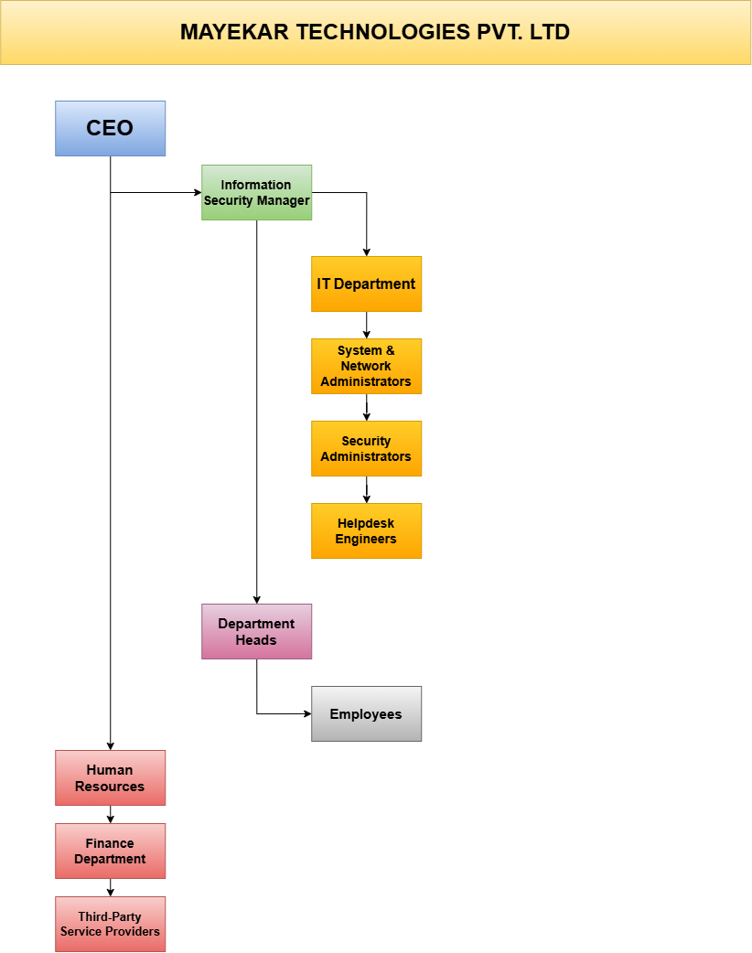
6. ISMS Governance Structure
The Information Security Management System (ISMS) shall be governed by:
- Chief Executive Officer (CEO)
- Information Security Manager
- ISMS Committee
- Department Heads
- Information Owners
- Asset Owners
- Process Owners
The governance structure ensures:
- Strategic Direction
- Risk Management
- Compliance Monitoring
- Resource Allocation
- Performance Monitoring
- Continual Improvement

7. Roles and Responsibilities
7.1 Chief Executive Officer (CEO)
Responsible for:
- Providing strategic leadership.
- Approving ISMS policies.
- Allocating resources.
- Reviewing ISMS performance.
- Supporting continual improvement.

7.2 Information Security Manager
Responsible for:
- Managing ISMS implementation.
- Performing Risk Assessments.
- Monitoring security controls.
- Coordinating Internal Audits.
- Reporting security performance.
- Managing incidents.
- Maintaining ISO 27001 compliance.

7.3 Information Technology Department
Responsible for:
- Network Security
- Server Security
- Endpoint Security
- User Access Management
- Backup Management
- Patch Management
- Logging & Monitoring

7.4 Human Resources
Responsible for:
- Employee onboarding
- Employee offboarding
- Background verification
- Security Awareness
- Confidentiality Agreements

7.5 Department Heads
Responsible for:
- Department Risk Management
- Information Classification
- Asset Protection
- Policy Compliance
- Incident Reporting

7.6 Employees
Responsible for:
- Following Information Security Policies.
- Protecting Company Assets.
- Reporting Security Incidents.
- Maintaining Confidentiality.
- Participating in Security Awareness Training.

7.7 Third-Party Service Providers
Responsible for:
- Contractual Compliance.
- Protecting Company Information.
- Reporting Security Incidents.
- Following Access Control Requirements.

8. Reporting Relationships
Position | Reports To
CEO | Board of Directors / Owners
Information Security Manager | CEO
IT Manager | Information Security Manager
HR Manager | CEO
Department Heads | CEO
Employees | Department Heads
Third Parties | Contract Owner / ISM

9. Communication and Escalation Matrix
Information Security matters shall be escalated through the following hierarchy:
Employee
⬇
Department Head
⬇
Information Security Manager
⬇
Chief Executive Officer
Critical incidents shall be immediately reported to the Information Security Manager.

10. Authority Matrix
Activity | CEO | IS Manager | Department Head | Employee
Approve Policies | A | C | I | I
Risk Assessment | I | A | R | C
Incident Response | I | A | R | R
Internal Audit | I | A | C | I
Management Review | A | R | C | I

Legend:
- A = Accountable
- R = Responsible
- C = Consulted
- I = Informed

11. Review and Maintenance
This document shall be reviewed:
- Annually.
- Following organizational restructuring.
- Following management changes.
- Following major business expansion.
- Following Internal Audit.
- Following External Audit.
- Following Management Review.

12. Review and Approval
This document shall be:
- Reviewed by the Information Security Manager.
- Approved by the Chief Executive Officer.
- Version controlled.
- Maintained within the ISMS Documentation Repository.
- Communicated to all relevant stakeholders.

13. Conclusion
A well-defined organizational structure establishes clear reporting lines, responsibilities, and governance required for an effective Information Security Management System. It ensures accountability, supports decision-making, strengthens risk management, and enables Mayekar Technologies Pvt. Ltd. to achieve and maintain compliance with ISO/IEC 27001:2022 while promoting continual improvement of information security practices.

